2. Clone using SSH keys

Already had a public SSH key (id_rsa) on my machine but with other identity(client’s mail account).

So, generated another SSH public key by providing another name for key,“id_rsa_gmail”.

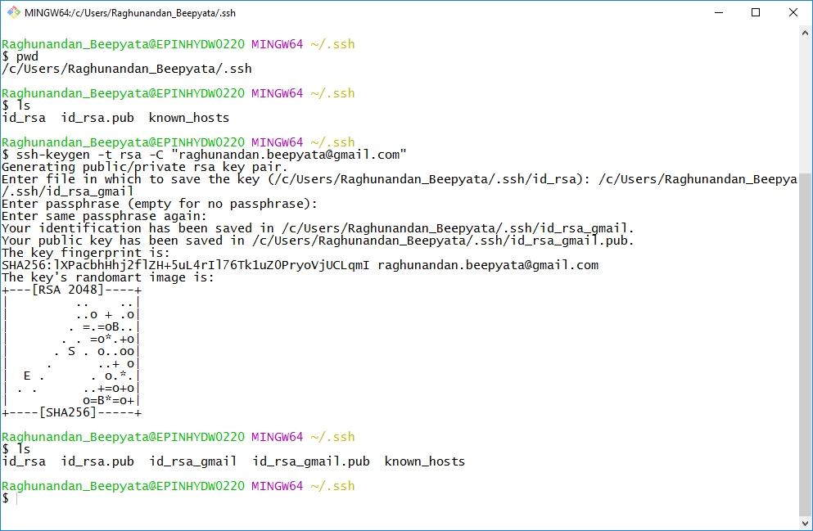

Copied the contents of the newly generated key…

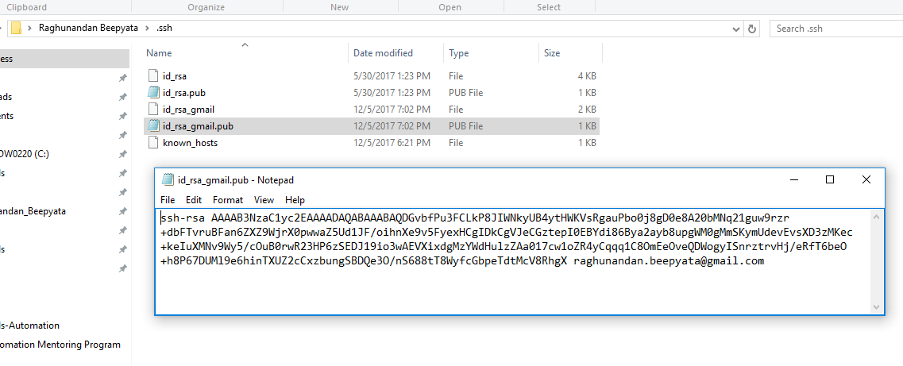

Added an SSH key in the GitHub by pasting the contents of the new generated key.

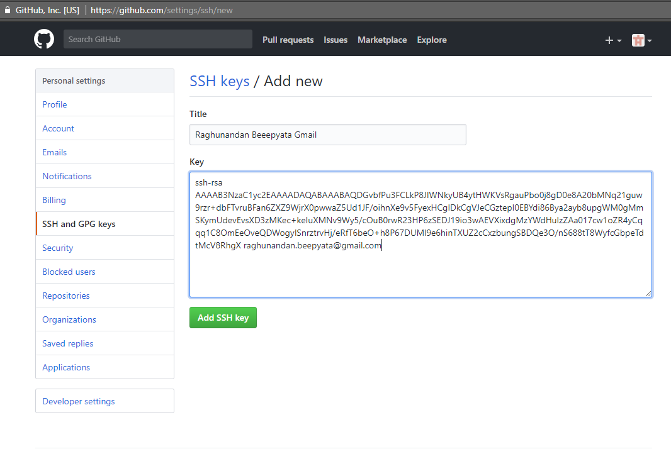

New SSH added with my gmail account identity.

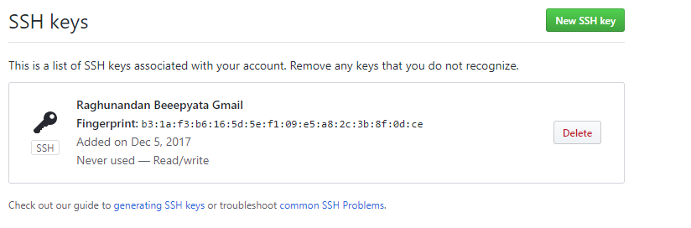

As the new key is saved with a unique name, this Identity had to be added to SSH so that it is recognized.

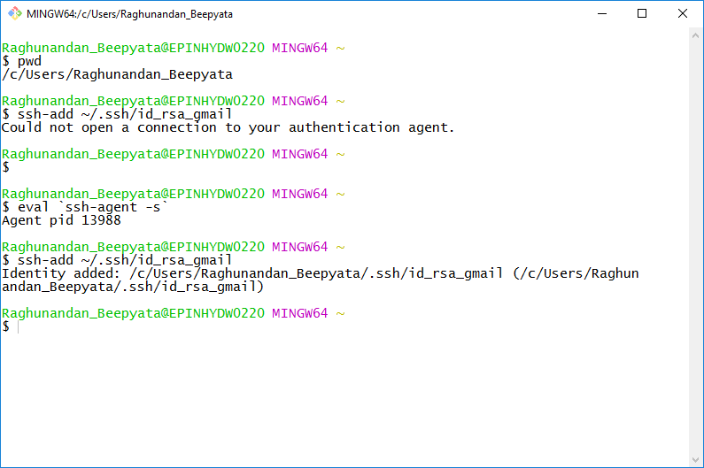

Created a configuration file to configure which host should use which Identity.

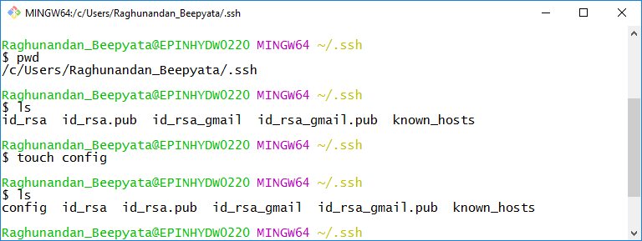

Done with the configuration per host.

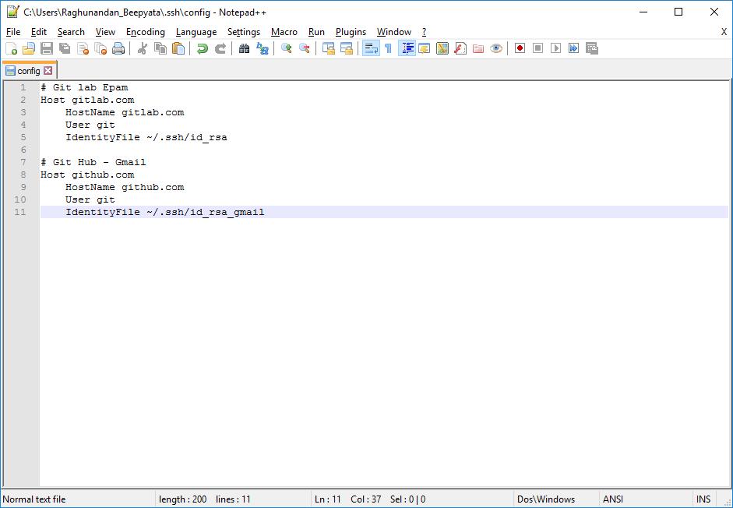

Cloned the module M2.1 repo using SSH.

